**Microsoft Sway**

**Start creating**

You can create a new Sway from scratch, from content in an existing file, or from a topic.

1. Select **Get started**.
2. On the **Welcome to Sway** page, select one of the following:
   * **Create New** - to start from scratch.
   * **Start from a topic** - to have Sway provide base content for you. Type your topic in the **Enter a topic** box, and then select **Create outline**.

**Note:** If Sway can’t find enough public data for the topic, Sway suggests related topics. Select the most relevant topic, and then select **Create Outline**.

* + **Start from a document** - to import content from an existing file. Browse to and select the file, and then select **Open**.

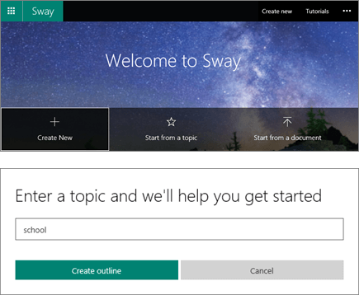

**Get to know the Storyline**

The Storyline is where you type, insert, edit, and format the content that tells your story. Here are some Storyline basics:

* Content is arranged in sequential order by adding “cards.”
* Each card holds the type of content you want—such as text, images, videos, and even Office documents.
* You can rearrange the cards at any time to suit your needs.

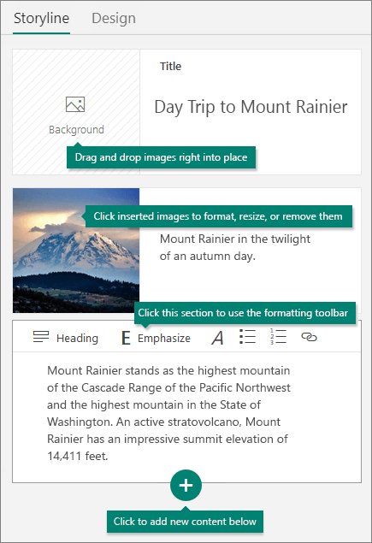

**Give your Sway a title**

1. Select the **Title your Sway** placeholder text shown in the first card on the Storyline.
2. Type a short but meaningful description of what your Sway is all about.

**Note:** When you create a Sway based on a topic or document, the title is prepopulated for you based on the topic or file name.

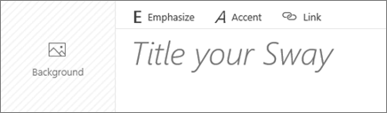

Add content in Sway

**Add content to your Sway**

1. Select the **+** icon at the bottom of the card you want to add content after.
2. Select text, image, video, or other content types.

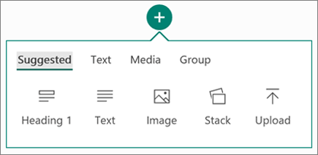

**Find content to add to your Sway**

You can search for and add additional content to your Sway, such as an image that is stored on your computer or mobile device. Sway can also search the web for relevant content, such as videos, and add it to your Sway.

1. Select **Insert** on the menu bar.
2. Select the content source menu, and then select the content source you want to search.
3. Type any search keyword or phrase into the **Search sources** box.
4. Select **Search** The Office Support site Toggle Search button. .

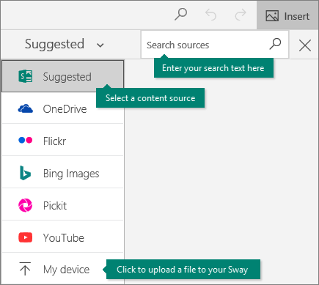

Design and share in Sway

**Change the design**

1. In the **Design** tab on the menu bar, select **Styles**.
2. Select the theme you want.
3. Select **Customize** in the **Styles** pane to adjust a specific part of the currently applied theme, such as color, font choices, and the emphasis of animation.

**Tip:** You can select **Remix!** in the **Styles** pane to apply a random design to your Sway at any time. Select **Remix!** repeatedly until you find a design that suits your taste.

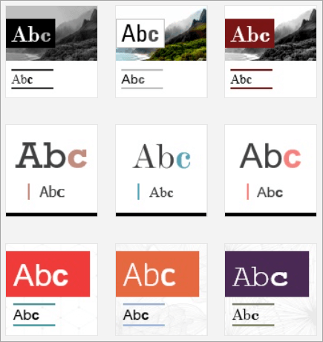

**Change the layout**

1. Select the **Design** tab on the menu bar.
2. In the **Styles** pane, select whether your content should scroll vertically, scroll horizontally, or appear like a presentation.

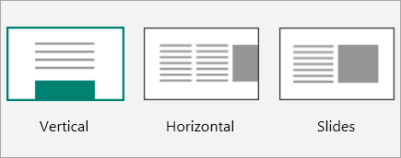

**Preview your Sway**

When you preview your Sway, you can see how it will appear to others when you share it.

* Preview your work in progress at any time by clicking the **Design** tab.
* Select **Play** on the top menu bar to fully experience your Sway (including any interactivity options that you’ve added).

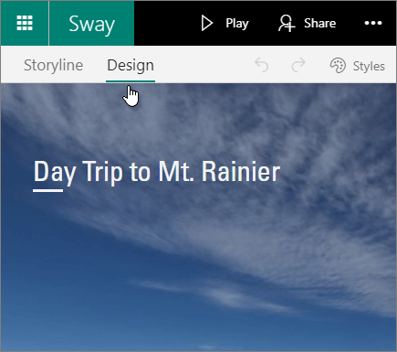

**Share your Sway**

It’s easy to share your finished Sways. Family, friends, classmates, and coworkers can see your creations on the web without signing up, signing in, or downloading anything.

1. Select **Share** on the top menu bar.
2. Select an option for sharing your Sway.

**Note:** Your choices on this menu depend on the type of account that you used to sign in to Sway. You can change the privacy settings for any Sway whenever you want more control over what you share.

For a more detailed look at all available sharing options, see [Share your Sway](https://support.office.com/en-us/article/share-your-sway-1cf853b8-ef7e-46b0-b704-003e58d28998).

